Appendix

Appendix 1 Structure A.1

Appendix 2 Power budget A.3

Appendix 3 Link budget A.5

Appendix 4 Communication diagram A.13

Appendix 1 Structure

Show a satellite appearance image to FigA.1．In addition, equipment layout of internal satellite is shown in FigA.2

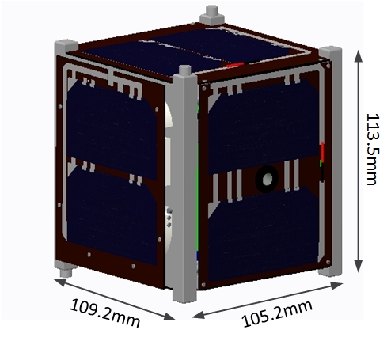 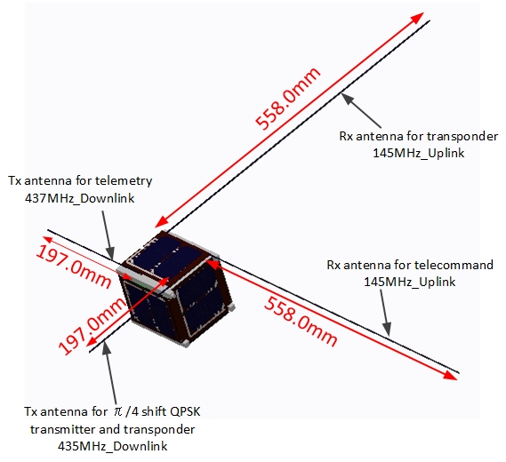

Fig.A 1 Satellite overview



Fig.A 2 equipment layout of internal satellite

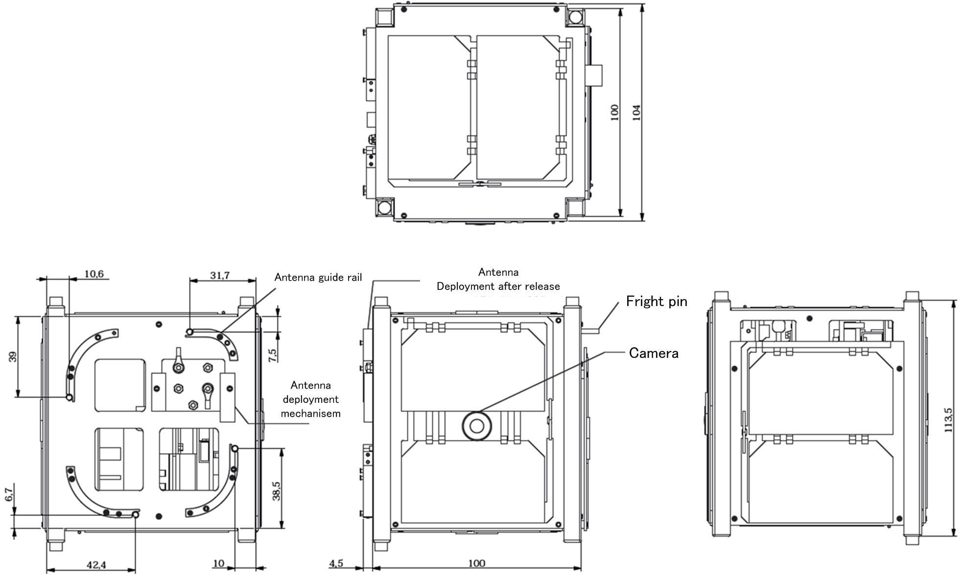

Fig.A.1 Drawing of satellite (launch configuration)

Appendix 2 Power budget

1. Power source

In the NEXUS, each two solar cell is attached to all surface. Daylight is available to charge a lithium-ion battery and the operation of each components．The specifications of Solar cells and the lithium ion battery are as shown in TableA.1 and TableA.2.

Table A.1 Solar cell

|  |  |
| --- | --- |
| Category | Specification |
| Type | Triple junction (InGaP/InGaAs/Ge) |
| Mount type | Body mount |
| Number of cells | 12cells (2 cells on each sides) |
| Arrangement | 2 in series and 6 in parallel |
| Dimension (1 cell) | 40.15mm x 80.15mm  (cell area: 30.18cm2) |
| Maximum efficiency | More than 27.5% |
| Averaged efficiency of power supply from the cells to the components | 90% |
| Avaraged daytime/round | 3897 sec/round |
| Averaged energy generation/ round | 6386 mWh/round |

Table A.2 Battery

|  |  |
| --- | --- |
| Category | Specification |
| Type | Li-ion |
| Nominal voltage | 3.7V |
| Nominal capacity (each battery) | 1880mAh |
| Number of batteries | 4 |
| Arrangement | 4 single-cells in parallel |
| Total capacity | 7520mAh |
| Averaged efficiency of power supply from the cells to the battery | 90% |

1. Daylight and eclipse

Estimate of daylight time and eclipse time are as shown in TableA.3.

Table A.3 estimate of daylight and eclipse

|  |  |
| --- | --- |
| Category | Data |
| Daylight | 3897 [sec] |
| Eclipse | 1980 [sec] |

1. Power consumption

In the electrical power analysis，We assume the eclipse time for the mode to be used primarily during normal operation. The discharge rate and depth of discharge of the battery was calculated by the operation of the battery only. As a result we confirmed that is within a tolerance. In order to determining the maximum amount of power that can be charged during one daylight, showing the value of power analysis of CW operation (during Daylight) a phase of normal operation. Power consumption at each operation phase is shown in TableA.4, and operation time and discharge current and discharge capacity at each phase are shown in Table A.5.

Table A.4 . Power consumption at each operation phase

|  |  |  |  |  |  |  |
| --- | --- | --- | --- | --- | --- | --- |
| State | Operation mode | Consumption current  [mA] | Consumption  Power  [mW] | Operation time[s] | Current consumption [mAh] | Power consumption [mWh] |
| daylight | CW operation（daylight） | 219 | 1008 | 3897 | 221 | 1092 |
| eclipse | CW operation（eclipse） | 273 | 1008 | 1980 | 112 | 555 |
| eclipse | FM downlink of 1200bps | 1203 | 4451 | 1980 | 495 | 2448 |
| eclipse | FM downlink of 9600bps | 1205 | 4459 | 1980 | 495 | 2452 |
| eclipse | QPSK downlink | 1086 | 4019 | 1980 | 862 | 2210 |
| eclipse | Digi-talker and SSTV operation | 1182 | 4375 | 1980 | 482 | 2406 |
| eclipse | CW and transponder operation | 1136 | 4202 | 1980 | 564 | 2311 |
| eclipse | CW and take a picture | 1188 | 4397 | 1980 | 465 | 1970 |
| eclipse | Sensing and antenna deployment | 2432 | 8997 | 1980 | 175 | 919 |
| eclipse | Real time image downlink | 1861 | 6887 | 600 | 296 | 1148 |

As a result ，consumption per one battery when the battery 4 Parallel (1 series) are shown in the Table A.5.

Table A.5

|  |  |  |  |  |  |  |  |
| --- | --- | --- | --- | --- | --- | --- | --- |
| State | Operation mode | Consumption current  [mA] | Consumption  power  [mW] | Operation time[s] | Current consumption [mAh] | C | DOD [%] |
| Daylight | CW operation（daylight） | 244 | 1121 | 245 | 1213 | - | - |
| eclipse | CW operation（eclipse） | 303 | 1121 | 125 | 540 | 0.0403 | 1.66 |
| eclipse | FM downlink of 1200bps | 1337 | 4946 | 550 | 2720 | 0.178 | 7.31 |
| eclipse | FM downlink of 9600bps | 1339 | 4954 | 551 | 2725 | 0.178 | 7.32 |
| eclipse | QPSK downlink | 1207 | 4466 | 958 | 2456 | 0.178 | 4.88 |
| eclipse | Digi-talker and SSTV operation | 1314 | 4861 | 536 | 2673 | 0.175 | 7.13 |
| eclipse | CW and transponder operation | 1262 | 4669 | 626 | 2568 | 0.168 | 8.33 |
| eclipse | CW and take a picture | 1320 | 4885 | 517 | 2189 | 0.176 | 6.9 |
| eclipse | Sensing and antenna deployment | 2702 | 9996 | 194 | 1021 | 0.359 | 2.579 |
| eclipse | Real time image downlink | 2068 | 7652 | 328 | 1275 | 0.275 | 4.366 |

The maximum amount of power that can be charged in once Daylight is 4546 [mWh].This is power generation of the solar cell in once daylight, and the amount of CW operation of normal operation phase. This result exceeds the target value, so we determined that can be operated in 4 Parallel.

Appendix 3 Link budget

It shows the link budget result of the transmitter below. From these tables, the link budget has been established. π / 4 shift QPSK transmitter and linear transponder technology demonstration is also possible. This link budget is supposed to altitude 530km.

Table A. 6　 Link budget of FM downlink



Table A. 7　Link budget of CW downlink and FM uplink



Table A. 8　Link budget of transponder



Table A. 9　Link budget of π/4 shift QPSK downlink



Table A. 10 FM downlink (GMSK and AFSK)



Table A. 11 FM downlink (FSK 600bps~9600bps)



Table A. 12 FM Uplink(FSK)



Appendix 4 Communication diagram

This satellite is communicated by some amateur radio station. The communication diagram is shown in



FigA.2 communication dyagram